H.T No
Regulations:
A17

Sreenidhi Institute of Science and Technology
(An Autonomous Institution)
Code No: 6AC46 Date: 13-July-2023 (AN)

B.Tech IV-Year I- Semester External Examination, July - 2023 (Supplementary)
LINEAR CONTROL SYSTEMS (ECE)

Time: 3 Hours Max.Marks:75

Note: a) No additional answer sheets will be provided.
b) All sub-parts of a question must be answered at one place only, otherwise it will not be valued.
c) Missing data can be assumed suitably.
Bloom's Cognitive Levels of Learning (BCLL)

Remember | L1 | Apply | L3 | Evaluate | L5
Understand | L2 | Analyze | L4 | Create | L6

Part - A Max.Marks:25
Answer all QUESTIONS

 |  | BCLL | CO(s) | Marks
1 | What are the characteristics of negative feedback? | L2 | CO1 | [2M]
2 | What is the need of controllers, compare PI and PD controllers? | L2 | CO2 | [2M]
3 | State Routh’s stability criterion. State their advantages and limitations of Routh Hurwitz criteria. | L4 | CO3 | [2M]
4 | Define the frequency domain specifications of second order system are  i) gain crossover frequency ii) phase crossover frequency, iii) phase margin iv) gain margin. | L1 | CO4 | [2M]
5 | Describe the necessity of lag compensator. | L1 | CO5 | [2M]
6 | Define the concept of state and write the advantages of state variable technique. | L1 | CO6 | [3M]
7 | What is meant by closed loop system? Illustrate with an example. | L2 | CO1 | [3M]
8 | Define marginal stability and conditional stability. | L1 | CO3 | [3M]
9 | What are the advantages of state space analysis? | L2 | CO6 | [3M]
10 | What will be the nature of impulse response when the roots of characteristic equation are lying on imaginary axis? | L2 | CO3 | [3M]
Part – B Max.Marks:50
ANSWER ANY FIVE QUESTIONS. EACH QUESTION CARRIES 10 MARKS.

 |  |  | BCLL | CO(s) | Marks
11. | a) | For the given signal flow graph below, obtain 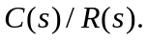 | L4 | CO1 | [5M]
 | b) | Write the differential equations, find the transfer function 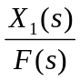 and also obtained force Voltage analogy for the system shown in figure.  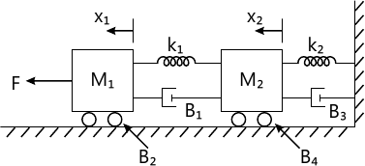 | L3 | CO1 | [5M]
12. | a) | Derive expressions for the steady state errors of type – 0, type – 1 and type – 2 systems excited by a unit step input. | L2 | CO2 | [5M]
 | b) | Find the step, ramp, and parabolic error coefficients and their corresponding steady state errors for unity feedback control system having the transfer function 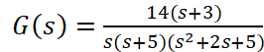. | L3 | CO2 | [5M]
13. | a) | Write the procedure for determining the angle of arrival and angle of departure. | L4 | CO3 | [5M]
 | b) | Sketch the root locus of a feedback system whose open loop transfer function is given by 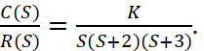  Comment on stability. | L5 | CO3 | [5M]
14. | a) | Explain about the correlation between time and frequency response analysis. | L2 | CO4 | [5M]
 | b) | A unit step input is applied to a unity feedback control system having open loop transfer function 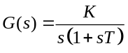. Determine the values of  and to have 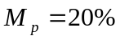 and resonant frequency 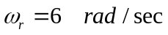. Calculate the resonant peak 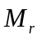. | L4 | CO4 | [5M]
15. | a) | Explain the concept of Nyquist stability criterion. | L4 | CO5 | [5M]
 | b) | The open loop transfer function of a unity feedback system is given by G(s)= 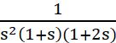.  Sketch the polar plot and determine the gain margin and phase margin. | L5 | CO5 | [5M]
16. | a) | Derive the expression for State Transition Matrix. | L4 | CO6 | [5M]
 | b) | A linear system is described by the following set of differential equations:  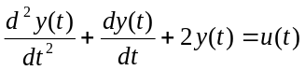.  Write (i) state equation , output equation in vector matrix form. (ii) Find the transfer function between the outputs and inputs of the system. | L5 | CO6 | [5M]
17. | a) | Explain the effect of feedback on the noise and sensitivity of the system. | L2 | CO1 | [4M]
 | b) | Consider the standard second order system, where 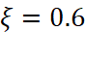 and 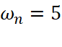 rad/sec. Calculate the rise time , peak time , maximum overshoot 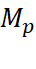, and settling time when the system is subjected to a unit-step input. | L4 | CO2 | [3M]
 | c) | Discuss the stability of the following system using Routh-Hurwitz criterion 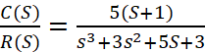 | L4 | CO3 | [3M]
18. | a) | The open loop transfer function of a system is 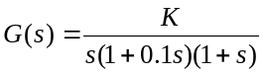. Determine the value of K so that the gain margin is 6 dB. | L3 | CO4 | [4M]
 | b) | List out the steps for Lead Compensator design in frequency domain using Bode Plot. | L3 | CO5 | [3M]
 | c) | Obtain the state model and transfer function of the given differential Equation + 6 + 7 = 5u. | L4 | CO6 | [3M]

-- 00 -- 00 –

